Assignment 3 – Implementing Distributed Shared Memory Using Java RMI
Due November 26

In this assignment, you will implement a Java RMI object-based DSM. In this system, data located at different sites is shared through a single virtual memory implemented through the DSM. The term object-based refers to the fact that all remote data is accessed as objects. Thus, if x is variable located at a given host, its values is accessed through accessor methods, such as x.get().

The main DSM component will serve all nodes with functions to register shared variables, obtain access to shared variables and maintain consistency.

The following are the main steps that should be implemented:

- A DSM server is started. The number of nodes/processes that will access the DSM is passed to it as a parameter. This number will be used by the server to maintain all data structures required to keep track of all shared variables as well as for consistency purposes.
- Each application process that wants to access the shared variables, should inherit from a DSM-parent class. This is done just so that all the code related to DSM communication is not mixed with the application code in each process. For example, if we have a distributed matrix multiplication application, where each participating node works with a row of the matrix. The application code in each process will be something similar to:

Public class rowmult {
Public rowmult(int rowi) {… } // constructor
Int multrow(row) {…}
Public static void main() {…}
}

Now, to make the code above be able to share variables from other application processes, it has to be able to connect to DSM, send its local variables, receive the other shared variables, execute operations to maintain consistency, etc… All this functionality could be embedded within the code, but it wouldn’t be an elegant or efficient solution. This is the reason each node should inherit from a DSM-parent class, which will have all the code to connect to DSM and execute all other DSM-related functions.

The DSM-parent class should have the following methods:

- connect – this method looks up for the DSM reference (use Naming.lookup) and sends the local data to it.
- Getcopy – this method gets a copy of all the shared variables from other nodes.
- Make_consistent – this method implements one of the consistency mechanisms covered in class.

Figures 1 and 2 illustrate the main steps to be executed.

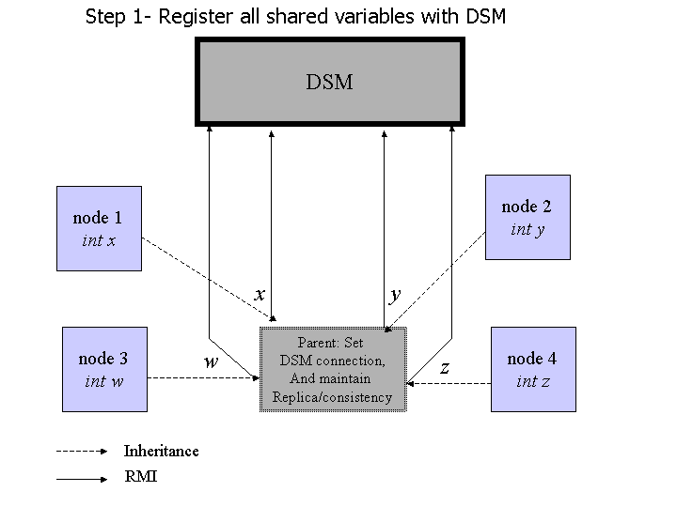
Figure 1 First step: register with the DSM
.

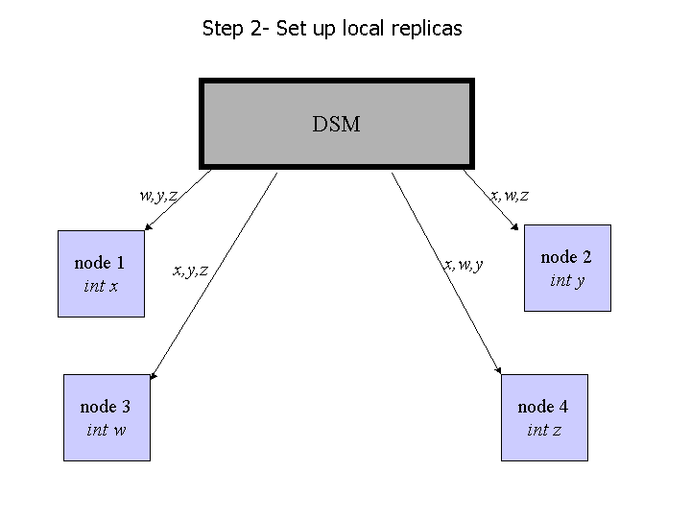
Figure 2 Set up local replicas

You will need to understand two new concepts in order to implement your solution. The first is the concept of reflection. Reflection is used by an object to get information on its class. For example, through Java’s reflection library, we can execute methods that return the methods of a class, the fields of a class, including the type and name of each field. Why do we need this? Well, if we want each node to send its shared variables to DSM, and then send the updated value for consistency purpose, we need to have a generic way to do this. In other words, how to we embed the knowledge of the structure of a class into our code? For example, the code below uses reflection to get the fields of the class and print the types and value of each field:

//*********************************************************************//
public class Usingreflection{

//These are the shared variables to be sent to DSM
public int x = 1;
public String y = "test";
public double z[];

public static void main(String args[]) throws java.lang.ClassNotFoundException, java.lang.IllegalAccessException, java.lang.InstantiationException
{
Usingreflection r = new Usingreflection();
Class aClass = r.getClass();

java.lang.reflect.Field [] f = aClass.getFields();// Get all the
// fields in this class
System.out.println("My data is: " );

for (int i = 0; i< f.length; i++)
{ System.out.println(f[i].toString()+ ", Name = " +
f[i].getName() + ", Type = " + f[i].getType().getName());
}
System.out.println("Value of f[0] is " + f[0].get(r));
System.out.println("Value of f[1] is " + f[1].get(r));
System.out.println("Value of f[2] is " + f[2].get(r));
}
}
//*********************************************************************//

The second concept is the concept of callback. Remember that in your first RMI assignment, a client always invokes a service on the server; and not the other way around, i.e., the server invoking a method on the client. In this assignment, after the DSM (our server in this case) receives the registration info from all nodes, with their shared variables, it has to send the complete set of shared variables to all nodes. This is illustrated in Figure 2 above. To enable such a communication, the server needs to callback the client and give the info needed. This is why we need to implement the callback. Callback is implemented the same way the usual requests to servers are made, i.e., through a remote interface. So now, along with the remote interface defined from the DSM server, you have to define the client functionality as a remote interface as well. For example:

Public interface clientside {
Public updatesharedvariables(Vector sharedvar) throws RemoteException;
}

The server is going to call the update method on the right client by something like this:

c.updatesharedvariables(sharedlist);

where c is an instance of a client that is stored on the DSM (the DSM will have to have some kind of vector of clients to keep track of all the nodes that are sharing variables), and sharedlist is the list of variables shared by all nodes.

Consistency Model:

You should implement one of the following consistency models: sequential, weak or causal.

Deliverables
- Your source code
- Documentation – this includes commented code as well as 1 to 2 pages describing your system: main components, their role, how you implemented consistency, design decisions, drawbacks, etc…. (this will be worth AT LEAST 20% of your grade)

